

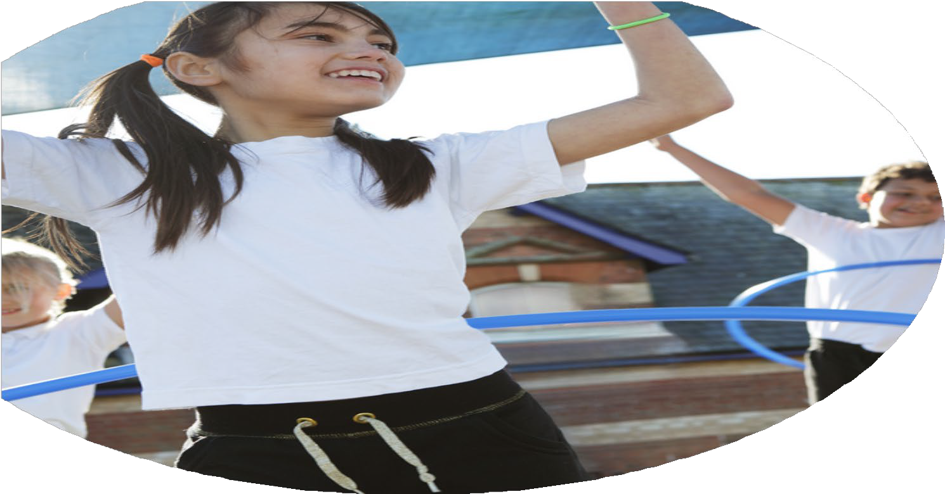





PE Funding

Evaluation Form

Commissioned by

Created by

Images courtesy of Youth Sport Trust

PE Funding Evaluation Form

It is intended that this template should be used as preparation for the completion of the statutory digital reporting tool being introduced this academic year. You can upload data (including swimming) from this template onto this platform once it becomes accessible.
Before you decide how you are going to use the funding for this academic year you should reflect and evaluate the impact of your use of the funding in 2024/25.
All spending of the funding must conform with the terms outlined in the Conditions of Grant document. The template is a working document that you can amend/update during the year.
Based on your evaluation of last year’s funding you should decide what you intend to do this academic year, how you will do it, and what impact you expect it to have.

It is important that the funding is used effectively and based on your school’s needs.
You must use the funding to make additional and sustainable improvements to the PE and sport in your school. You must develop and add to the PESSPA activities that your school already offers.

Summative digital reporting from June 2025 will continue to include swimming and water safety information therefore funding can be used to provide top-up lessons where necessary to ensure pupils meet national curriculum swimming requirements.

We recommend that you start by reflecting on the impact of current provision and reviewing your previous spend

What went well? | How do you know? | What didn’t go well? | How do you know?
Increasing all staff’s confidence, knowledge and skills in teaching PE and sport. All staff have developed greater confidence and understanding when delivering high-quality PE. Planning now follows the Woodthorpe Progression of Skills, supporting consistency and clear progression. ECTs have particularly benefited from mentoring and CPD focused on skill progression, differentiation and effective feedback. | Lesson observations, planning scrutiny and staff feedback show increased confidence and improved understanding of PE teaching. ECTs have developed greater subject knowledge when teaching specific KS1 and KS2 skills, tactics, game structures and providing effective feedback. | The continued increase in transport costs has made it more challenging to provide equal access to competitions and festivals. | Transport costs have increased, placing additional pressure on the PE budget and requiring careful consideration of which events the school can attend while maintaining opportunities for pupils to participate.
Curriculum coverage and skill progression. The PE curriculum meets national requirements, with clear progression from EYFS to Year 6. Lessons build on prior learning, with age-appropriate skills and consistent expectations across classes. | Curriculum mapping, planning scrutiny and end-of-year assessment information show clear progression of skills and improved numbers of pupils achieving expected PE standards. | Opportunities for pupils to experience a wide range of sports and competition rules have been dependent on the competitions and festivals available through the school’s affiliation. | The range of external competitions and festivals offered does not always provide opportunities to experience every sport taught within the curriculum or develop specific competition rules and formats.
Pupil engagement in physical activity. More pupils are active during break times and after school. Participation in clubs and competitions has increased, with pupils showing enthusiasm and pride when representing Woodthorpe. | Participation registers, competition records and pupil voice demonstrate increased engagement, enjoyment and participation in physical activity. | Fewer schools attending some events has reduced opportunities for regular competition against a wider range of schools. | Competition and festival attendance records show that some events have had lower numbers of participating schools, limiting the variety of competitive experiences available to pupils.
Increased opportunities for competitive sport and representation. Pupils have had more opportunities to participate in competitions and festivals, developing teamwork, resilience and sportsmanship. | Competition records, staff observations and pupil feedback demonstrate increased participation and positive attitudes towards representing the school. | Balancing curriculum development, staff CPD and opportunities for external competition remains challenging within available time and resources. | Staff feedback and monitoring indicate that continued support and development are needed to ensure all staff can confidently deliver a broad range of activities while maintaining curriculum consistency.

What are your plans for 2025/26? | How are you going to action and achieve these plans?
1. Engagement of all pupils in regular physical activity Ensure all pupils have opportunities to achieve at least 30 minutes of physical activity during the school day. Promote equal access and participation for all pupils, including opportunities that encourage greater participation from girls. | Intent: Increase daily physical activity and provide inclusive opportunities for all pupils to participate.  Implementation:  • Promote active break and lunchtime activities.  • Use playground zones to provide structured games and activities.  • Provide a range of accessible playground equipment.  • Incorporate active learning, movement breaks and sensory circuits where appropriate. • Monitor participation and pupil voice to identify barriers to engagement.  • Provide targeted opportunities such as girls' football, dance and other enrichment activities.
2. Raise the profile of PE and sport across the school as a tool for whole-school improvement Develop pupil leadership and use PE and sport to promote teamwork, resilience, confidence, healthy lifestyles and positive relationships. | Intent: Give pupils greater ownership of physical activity and develop leadership skills.  Implementation:  • Develop a school-wide Sports Ambassador/Play Leader programme.  • Train pupils to lead playground games and activities.  • Continue to develop active lunchtimes where pupils can practise and consolidate skills for festivals and competitions.  • Promote the Chesterfield FC Primary Stars values: Be Fair, Be Connected, Be Inspiring and Be Ambitious.  • Celebrate sporting achievements through assemblies, displays and the school website.
3. Increase the confidence, knowledge and skills of all staff in teaching PE and sport Ensure teachers have the knowledge, skills and confidence to deliver structured, progressive and inclusive PE lessons. | Intent: Improve the quality and consistency of PE teaching across school.  Implementation:  • Work with Chesterfield FC/CCFC coaches to identify staff CPD needs.  • Provide coaching, modelling and mentoring for teachers.  • Prioritise CPD around skill progression, differentiation, game tactics and inclusive teaching.  • Support ECTs to develop their subject knowledge and confidence in teaching PE.  • Use the Woodthorpe Progression of Skills to ensure lessons build systematically on previous learning.
4. Provide a broader experience of sports and physical activities Increase opportunities for pupils to experience a wide range of sports, including activities that may appeal to pupils who do not engage as readily with traditional team sports. | Intent: Broaden pupils' sporting experiences and increase participation.  Implementation:  • Offer a varied programme of after-school clubs and enrichment activities.  • Rotate club opportunities across the year in response to pupil interest and participation.  • Provide alternative activities such as dance, yoga, fitness circuits and other non-traditional sports.  • Use pupil voice to identify activities pupils would like to experience.  • Link activities to upcoming festivals and competitions where appropriate.
5. Increase participation in competitive sport Provide more pupils with opportunities to participate in festivals, competitions and inter-school sporting events. | Intent: Develop pupils' confidence, teamwork, resilience and sportsmanship through competition.  Implementation:  • Use the PE budget to support competition entry fees, transport and appropriate equipment.  • Increase participation in local competitions and festivals.  • Provide opportunities for pupils to practise and consolidate skills before competitions. • Capture pupil voice following competitions and festivals.  • Use participation data to monitor which pupils and groups are accessing competitive sport.  • Explore opportunities to host or participate in inter-school events.
6. Continue to develop inclusive PE and physical activity for SEND pupils Ensure pupils with SEND can access physical activity in a way that meets their individual needs, abilities and sensory requirements. | Intent: Remove barriers to participation and provide accessible, enjoyable physical activity opportunities.  Implementation:  • Use adapted activities and the STEP framework to support differentiation.  • Develop sensory circuits and movement opportunities for pupils who benefit from additional regulation and physical activity.  • Provide smaller-group or quieter activities where appropriate.  • Explore sensory-friendly activities including yoga, dance and low-impact exercise.  • PE Lead and SENDCO to research accessible local opportunities, including SEND festivals and quieter community sessions.  • Seek advice from the Inclusion Support Advisory Teacher regarding appropriate sensory circuit resources and equipment.  • Purchase resources to support inclusive and sensory-friendly physical activity.

What impact / intended impact / sustainability are you expecting? | How will you know? What evidence do you have or expect to have?
- Ensure 30 minutes of daily physical activity for all pupils  • Pupils regularly engage in at least 30 minutes of physical activity each day.  • Increased participation in active play and physical activity.  • Improved energy, concentration and readiness to learn.  • Increased participation of girls in PE, clubs and physical activity  • Reduced gender differences in participation.  • Active routines become embedded within the school day and are sustainable beyond the funding period. | • Staff observations and monitoring.  • Pupil voice and surveys.  • Active break/lunchtime participation records.  • Club registers.  • Termly participation audits.  • Staff feedback regarding pupils' focus and engagement.  • Monitoring of participation by gender and year group.
- Develop structured and inclusive active break and lunch sessions  • More pupils actively participate in structured games during break and lunchtime.  • Increased inclusion of pupils who may be less confident in traditional sports.  • Pupils develop social skills, teamwork and confidence through active play.  • Play Leaders and staff have the skills to sustain structured activities throughout the year. | • Playground observations.  • Pupil voice and surveys.  • Participation monitoring.  • Behaviour and lunchtime incident logs.  • Staff and Midday Supervisor feedback.  • Pupil leadership records.  • Monitoring of equipment use and playground activities.
- Increase the confidence, knowledge and skills of all staff in teaching PE and sport  • Staff demonstrate increased confidence in planning and delivering high-quality PE.  • Teachers have improved subject knowledge of skills, tactics, differentiation and assessment.  • Emerging gaps in pupils' PE skills are identified and addressed.  • A consistent approach to PE is embedded through the Woodthorpe Progression of Skills and PE scheme.  • CPD and mentoring support sustainable improvement in teaching practice. | • Lesson observations.  • Planning scrutiny.  • Staff confidence questionnaires  .• Staff feedback following CPD.  • PE assessment information.  • Progression of Skills monitoring  .• Evidence of staff applying CPD within lessons.
- Expand the range of physical activity opportunities  • Pupils experience a broader range of sports and physical activities.  • Increased participation from pupils who may not engage with traditional competitive sports.  • Increased variety of after-school clubs and enrichment opportunities.  • Pupils develop new skills and discover activities they enjoy.  • Pupil voice informs future provision, supporting sustainable participation. | • Club registers and participation data.  • Termly audits of clubs and enrichment opportunities.  • Pupil voice and surveys  .• Participation data by year group and gender.  • Staff/coaches' feedback.  • Pupil feedback following new activities.  • Records of external providers and enrichment opportunities.
- Increase participation in festivals and competitions  • Increased numbers of pupils participating in festivals and competitions. Wider participation across year groups and genders.  • Pupils develop teamwork, resilience, confidence and sportsmanship.  • More pupils have opportunities to represent Woodthorpe.  • Competitive sport becomes a visible and valued part of school life. | • Competition and festival registers  .• Participation records by year group and gender  .• Pupil voice and feedback.• Competition results and records.  • Staff and coach feedback.  • Photographs/newsletters/Dojo updates celebrating participation.  • Termly review of participation and opportunities offered.
6. Inclusive PE for all pupils, including SEND• SEND pupils  participate actively and confidently in PE and physical activity.  • Adapted planning and inclusive teaching strategies reduce barriers to participation.  • Pupils have regular opportunities to develop physical skills at an appropriate level.  • Sensory circuits and adapted resources support individual needs where appropriate.  • Inclusive PE approaches become embedded within everyday teaching and provision. | • Lesson observations and monitoring.  • Pupil voice and feedback.  • Staff/SENDCO feedback.  • Participation records.  • Individual support plans where relevant.  • Evidence of adapted planning and use of the STEP framework.  • Sensory circuit/resource audits.  • Behaviour and engagement observations.  • Feedback from external SEND activities and festivals.

What impact/sustainability have you seen? | What evidence do you have?
- Daily physical activity  There has been an increase in opportunities for pupils to be physically active throughout the school day. Active break and lunchtime activities have encouraged pupils to participate regularly. Participation by girls has increased through targeted activities and clubs. These routines are now embedded within school practice and can continue beyond Sport Premium funding. | • 90% of pupils participated in active break/lunchtime activities.  • Club registers show participation increased from 25 pupils in 2024/25 to 30 pupils in 2025/26.  • Pupil voice showed 75% of pupils felt they had regular opportunities to be active.  • Staff observations identified improved engagement and focus following physical activity.
- Active break and lunchtime provision  Structured activities have increased participation and provided pupils with more purposeful opportunities to be active. Pupils have developed teamwork, cooperation and confidence. The use of pupil leaders and trained staff provides a sustainable model for continuing active play. | • 10 Play Leaders trained.  2 structured activities offered each week.  • Lunchtime observations show increased participation in organised games.  . • Pupil survey: 80% of pupils reported enjoying active lunchtimes.
- Staff confidence and PE teaching Staff confidence and subject knowledge have improved.  Teachers are increasingly confident in teaching specific skills, tactics, game structures and providing feedback. The Woodthorpe Progression of Skills has provided greater consistency across the school and supports sustainability. | • 100% of staff reported increased confidence in teaching PE following CPD.  • 80% staff members received PE CPD/coaching.  • Planning scrutiny shows the Progression of Skills being used consistently.  • Lesson observations demonstrate improved differentiation and progression.
- Broader range of physical activity  Pupils have experienced a wider range of sporting and physical activities, including opportunities beyond traditional team sports. This has helped engage pupils with different interests and abilities. Pupil voice will continue to inform the club and enrichment programme. | • Different sports/activities offered during 2025/26.  • 2 x a week after-school clubs delivered across the year.  • 30% of pupils participated in enrichment activities.  • Participation records demonstrate engagement across different year groups and genders.  • Pupil voice identified football, multi-sports and dance as popular choices.
- Inclusive PE and SEND There has been increased focus on removing barriers to participation for pupils with SEND.  Adapted activities, sensory approaches and differentiated teaching have supported pupils to participate at their own level. This approach is becoming embedded within PE planning and whole-school provision. | • Pupils began accessing adapted/sensory physical activity opportunities.  • Adaptations are evident in PE planning and lesson observations.  • Staff feedback indicates increased confidence in adapting activities.

